by Lorri Timbs
teacher: Ms. Braniff
Eng. 102
25 January 1999
THESIS STATEMENT:
In a classic story of the experiences shared by over 350,000 Polish immigrants of the 1900's era, Jacob Dyrek left Poland and came to America.

I. Reasons the Poles left Poland
A. Threat of war
B. Ineffectual Rule of Czar Nicholas
C. Religious persecution
D. Poverty

II. Preparing for the journey
A. Exit papers
B. Packing
C. Getting to a port
D. Booking passage
E. Health inspections

III. The journey
A. The conditions on ship
B. Waiting in port

IV. Arrival on Ellis Island
A. Legal
B. Emotional
C. Examinations

V. Arrival in Chicago
A. Living quarters in Pullman
B. Employment
C. Making adjustments
VI. Conclusion
A. How Jacob's story compared to other immigrants

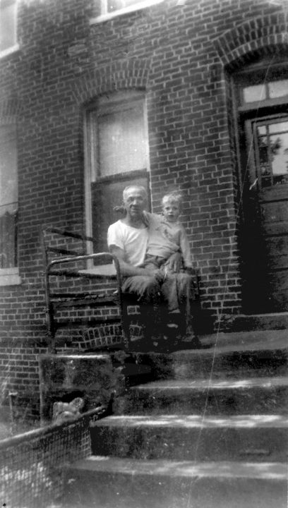 | Illustration: Fig 1:  Jacob Dyrek sitting on front porch with his grandson, Jack A. Dyrek, in his lap. 1945.  Photo provided by Mildred Dyrek

In 1913, at the age of 30, Jacob Dyrek, a Pole, embarked on a journey that would carry him across the globe.
Following in the footsteps of thousands who had gone before him and followed by thousands who would come after, Jacob Dyrek's story is a classic tale of the experiences shared by more than 350,000 Polish immigrants to America between 1890 and 1920.
Jacob's journey began in his hometown of Limo Nova, Poland and was typical of the journey taken by thousands of other Polish immigrants during that decade. Jacob and the others were fleeing from war-torn Poland, sensing that a major Polish revolution was to be soon at hand. Russia, Germany and Polish freedom activists had been squabbling for more than 100 years over the rule of this area, and the ineffectual rule of Czar Nicholas offered little hope of protection to the Polish citizens. The Jewish religion was practiced only in secrecy in some areas because of the fear of political reprisal and persecution. Poverty was a wide spread reality to many farmers like Jacob who had to obtain work in the factories of German "occupied" Poland to gather enough money for the trip to America.

Illustration: Fig 2:  Jeff Dyrek, grandson of Jacob, front left, with other kids from Pullman. 1958. Alfie in back right  Photo provided by Mildred Dyrek | 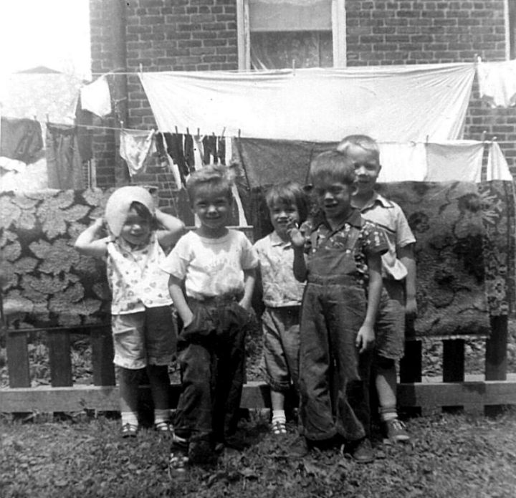

Anyone wishing to leave Poland was required to obtain written permission in the form of exit papers.
To ease the process of admission to America, a letter from family or friends in America, promising care and employment for the new immigrant was very desirable. Jacob received his request for immigration and obtained a letter of welcome from his sister in America. (Dyrek). Packing only pillows, clothes, precious possessions and some food, Jacob and his family set out for America where they hoped to find a better life. America was a land with "Streets of gold," or so the rumor said. A land of golden opportunities. With the legal paperwork out of the way and his decision to leave his homeland made Jacob Dyrek, his wife and one child, begin this long and arduous journey. One family among the two and one half million immigrants who would pass through the gates of Ellis Island to begin a new life in America in what would later be called the greatest migration in history. (Severn)
Jacob and the others left just in time. World War II broke out in Europe in 1914. The first step of what would be a four week trip began by rail from a town named Limo Nova, to Warsaw, and then on to Gdansk, Poland. Once in the port of Gdansk Jacob and his family waited among thousands of other hopeful immigrants of all nationalities, German, Bohemians, Slovakians, Croatians and more.
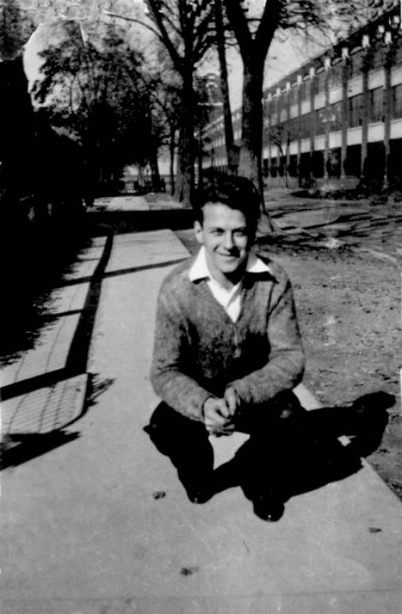 |  | Illustration: Fig 3:  John Dyrek, son of Jacob, in front of his Pullman house across from the Pullman factory. 1938.  Photo Provided by Mildred Dyrek

Passage on a steam ship was booked to Ellis Island for about thirty dollars.
A pre-boarding medical exam and de-lousing session were performed by employees of the shipping line. The ship line could be fined up to one thousand dollars for any unhealthy, unacceptable immigrant brought to Ellis Island, and then forced to provide free passage back to the port of origin for those not permitted into America. Also, the threat of disease spreading rampant on board ship caused many travelers to be refused access onto the ships. (Severn).
Their journeys must end in the Gdansk port, after the medical examiners denied them passage and sent them home. For those like Jacob who were approved for travel, a trip which would last from 8 to 14 days began as they were loaded into the steerage area like baggage. And despite the pre-screening in port, disease ran rampant among this human cargo. (Journey to America). Many died, and others were so ill before the voyage's end that they were detained on Ellis Island. Sanitation was primitive on board ship, and the overcrowding of passengers was inhuman. The smell of vomit and human body odor could only be escaped by crowding onto the deck of the ship for fresh air. (America: The Huddled Masses). One of the many things that Jacob Dyrek had in common with the other immigrants was a dream for a better life in America. This hope alone made the journey bearable.

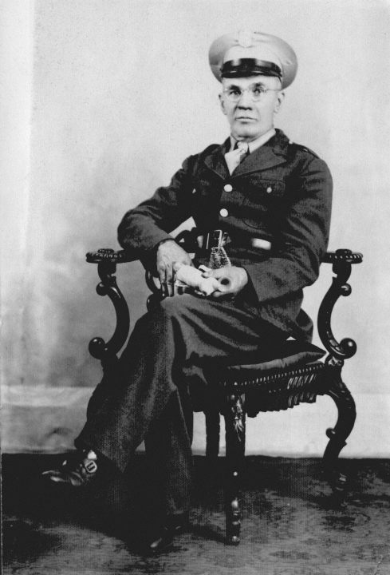 | Illustration: Fig 4:  After Leaving the Pullman factory, Jacob Dyrek worked as a guard in the Post Office. He is shown here, in 1945, wearing his guards uniform.  Photo provided by Mildred Dyrek

When Jacob and his family arrived on Ellis Island, a federal immigration depot for working class immigrants, a battery of test and inspections and legal paperwork began.
New immigrants were checked for lice, physical health, emotional stability and intelligence to determine whether or they may become a burden or an asset to America. About two percent of the perspective immigrants failed to pass these tests and were denied access to America. Another twenty percent were detained or rejected because of illness or problems with legal paperwork. (Brownstone).
Many of those who were ill, while on Ellis Island, never recuperated. Over thirty five-hundred immigrants died on Ellis Island during these massive migratory years around the turn of the century, fourteen hundred of these were children. Many of these children died from exposure to the cold while being ferried to hospitals on the mainland for treatment. (Chermayeff).

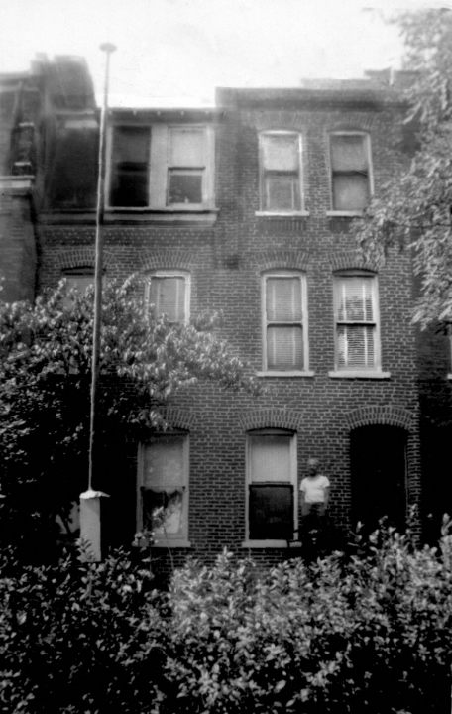 | Illustration: Fig 5:  The Pullman house owned by Jacob Dyrek at 10512 S. Maryland, 1946.  Photo provided by Mildred Dyrek

Fortunately Jacob's family suffered no ill fortune on their stay at Ellis Island.
Approved for admittance to America, Jacob and his wife and son joined the ranks of the three hundred and fifty thousand Polish immigrants who came to the great cultural melting pot of America between the years of 1890 and 1920. (www.chapter18). Jacob traveled from New York to Chicago Illinois by rail to meet with his sister and her husband, Wally Watroba, to begin his new life. Nearly three fourths of all the Polish immigrants to Illinois settled in Chicago in communities mostly on the North side. Neighborhoods such as Avondale, Irving and Belmont were on the north side and the south side towns included Pullman, Calumet City, and Brighton. (www.Pullman). These communities were easy to live in for the Polish. Work was easy to find in the factories and Polish was one of the main languages spoken. These communities had been established years before by homesick immigrants in an attempt to recreate the a feeling of culture they had left behind. (America). Jacob's family located in Pullman on Maryland Avenue in a tenement building built to house Pullman factory workers. Three generations of Dyrek’s lived in this building which Jacob later purchased. (Dyrek interview).
Jacob Dyrek and his wife Anna had two sons, Joe, who made the trip with them, and John, who was born shortly after the journey. They also had three daughters, Helen who was interviewed to get Jacob's story, Florence, and Annie. Jacob's son, John, married and also had five children who were raised in this Maryland street apartment building in Pullman. Jacob died at the age of eighty-three. John died at the age of sixty-two.
Webmasters Note; Every time I go back and see this old house, it is empty and it looks like it was bombed out. Recently my cousin sent me and my brothers some pictures of my grandmother who died shortly after moving to Pullman. The interesting thing is that as soon as my older brother looked at the picture, he yelled, "That's the woman that I saw in the basement." This refers to when he was a kid, in the early fifties, when he would go into the basement, he would see a ghost lady. My brother has never seen his grandmother because she died before he was born. Until recently, he has never even seen a picture of her. Did he see his grandmothers ghost?

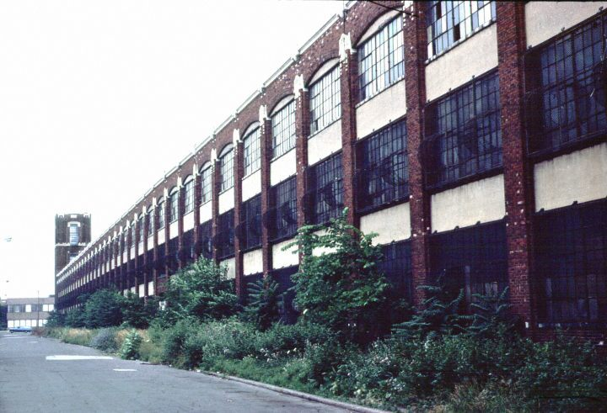 | Illustration: Fig 6:  The northern most building of the Pullman factory located at 105th and. Maryland on the south side of Chicago.  Photo taken Aug. 1980. Provided by Jeffrey C. Dyrek

John's son, Jeffrey, Jacob's grandson, was also interviewed to gain a clearer image of what life in this Pullman ethnic area was like.
Jeff's memories are remarkably clear and vivid. He starts his part of this story by describing his grandpa as, "A mean, cross, old man, who could speak Russian, Italian, German, and Polish fluently," which probably explains his success in the Pullman area.

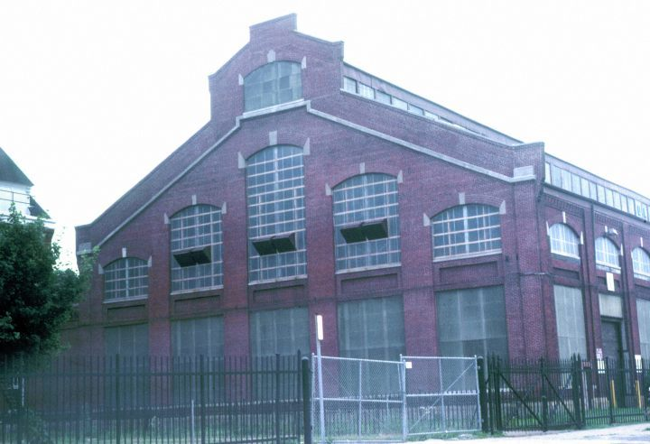 | Illustration: Fig 7:  Pullman factory building  located at about 108th St., Midway between the north and south boundaries of the Pullman factory complex.  Photo taken Aug. 1980 by Jeffrey C. Dyrek
Jacob's grandson also remembered that the apartment where he and his four brothers, mother and father lived was way too tiny for seven people. (See Fig 5 ) There was no bathtub or hot water. They had to use a wash bucket for their bathing and laundry. Gas was the source of heat and light in this tiny three-room home. The only plumbing consisted of one sink and a toilet. The five children shared one bedroom which was really one half of the kitchen divided off by curtains. "The house was across the street from the factory grandpa and dad worked in," stated Jeff Dyrek. (Dyrek) (See Fig 6) This description is classic when compared to the living conditions of other tenement apartment dwellers in the Chicago area. The Pullman factory closed in 1958, (netscape: Chicago Landmarks) and the Dyrek's moved from the apartment building within the following year.

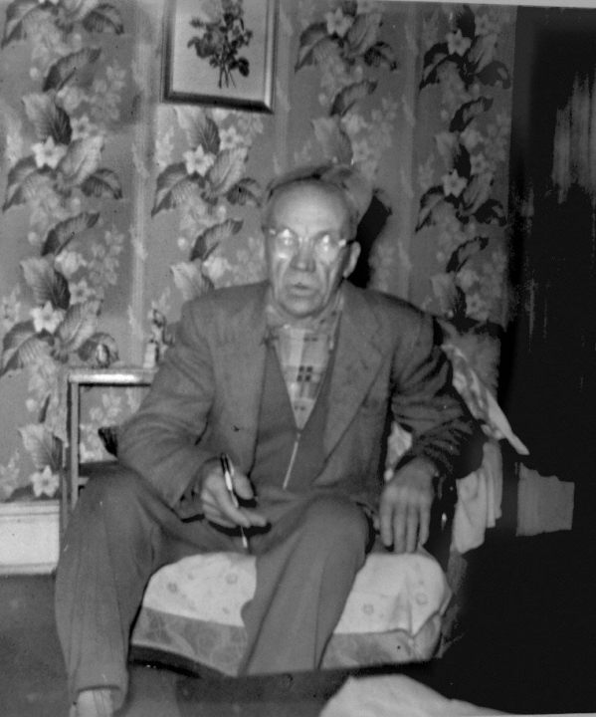 | Illustration: Fig 8:  Jacob Dyrek sitting in living room of his Pullman home. 1960,  Photo provided by Mildred Dyrek
Jacob Dyrek's immigration to America was a success story. Surviving the long journey and rigorous testing of Ellis Island, traveling across America to Chicago. Jacob Dyrek left behind a legacy that still lives on today. The significant impact that Jacob, and the other three hundred and fifty thousand Polish immigrants had on America will always be remembered. Supplying the labor and talent needed to help this country becomes one of the most powerful and culturally diverse nations in the world. (Reardon).
The United States of America truly is a land with streets paved in golden opportunities.

Works Cited
America, The Huddled Masses, Vol. 9. Videocassette. The John D. & Catherine Macarthur Library. 1973
Brownstone, David and Irene Franck. "Island of Hope, Island of Tears. Rawson: New York. 1991. pg 31
Chermayeff, Ivan and Fred Wasserman. Ellis Island: An Illustrated History of the Immigrant Experience. MacMillan: New York. 1991 pg 17...
Dyrek, Helen. Telephone interview. 20 Jan. 1990
Dyrek, Jeffrey C. Telephone interview. 19 Jan. 1990
Dyrek, Mildred. Telephone interview. 20 Jan 1990
Illustration: cover page: Fig. 1: Jacob Dyrek and his grandson Jack sitting on porch: Provided by Mildred Dyrek. 1945
Illustration: cover page: Fig. 2: Jeffrey Dyrek and his friends in Pullman back yard: Provided by Mildred Dyrek: 1958

